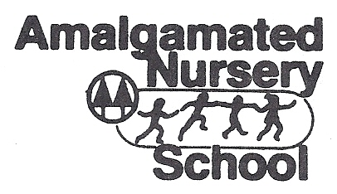
3980 Orloff Avenue
Bronx, New 10463
718-543-8688
REGISTRATION APPLICATION for school year: 2023-2024

Child’s Name: ______________________________________________ Date of birth: ___________________________
Address: __________________________________________________ Telephone: ___________________________
__________________________________________________ Email: _________________________________
Name of parents:(Parent): ____________________________________ Occupation: _____________________________
Work Address: ____________________________________ Cell or Work Phone #: ____________________
(Parent): ____________________________________ Occupation: ____________________________
Work Address: ____________________________________ Cell or Work Phone #: __________________

Type of program:
Little Hands 2 (M,Th)____
Little Hands 3 (M, W, Th)___
*Days of service may change based on enrollment*
Healthy snacks will be provided with funding from the CACFP food program each morning.
A registration fee must accompany this application. The registration fee is non-refundable.
Programs will be offered only if there is sufficient registration.

Registration fee: ______________________________ JCAC Y/N: ____________________________________

Signed: _____________________________________ Date: _______________________________________

SPONSORED BY THE JOINT COMMUNITY ACTIVITIES COMMITTEE OF THE AMALGAMATED & PARK RESERVOIR COOPERATIVES.

